Positive Behavior Intervention and Supports in the Home



Parenting Tips and Strategies

August, 2010

A MiBLSi PROJECT

Positive Behavior Interventions and Support (PBIS)

“If you know why,
you can figure out how….”
W. Edward Deming

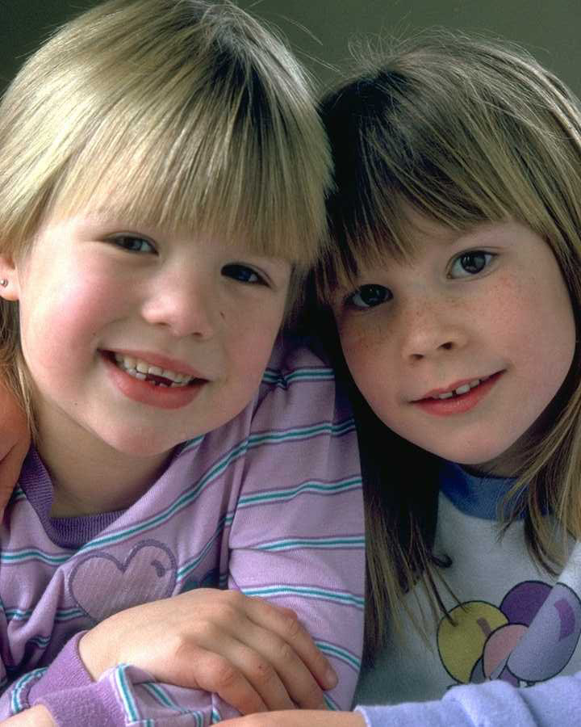

- All behaviors meet needs

- Positive approaches teach children a better way to meet their needs

- Behavior is related to the environment in which it occurs

- Behavior changes as children mature and develop new skills

Table of Contents

What is Positive Behavior Intervention and Support? 1
Features of PBIS 2
Section 1: The Big Ideas 3
PBIS in the Home 4
Define Behavior Expectations 5
Matrix and Charting Routines 10
Matrix/Chart 13
Visual Supports 14
Teach and Practice 16
Monitoring Behavior/Expectations 19
Acknowledge Appropriate Behavior 21
Correct Behavior Errors 23
Consequences that Teach 29
Problems with Punishment 30
Things to Do Instead of Spanking 31
Section 2: Suggestions, Strategies and Ideas 36
Keys to Successful Parenting 37
Ways to Make Waiting Fun 41
Doing Homework 42
Respecting Adults 43
Controlling Temper and Anger 44
Teaching Responsibility 45
Different Ways to Say “No” 46
Section 3: Handling Specific Problem Behaviors 47
When is Behavior a Problem 48
Taking a Broader Look at Specific Behaviors 49
Possible Strategies for Specific Behavior 50
Disrespect 50
Defiance/Noncompliance 51
Aggression 52
Bullying 53
Qualities of Strong Families 54
Appendix 55
- Visual Supports
- Specific Problem Behavior Worksheet
- Matrix

“To discipline is to guide, to lead, to teach, to nurture, to support, to love, to set free…”

What is POSITIVE BEHAVIORAL
INTERVENTIONS AND SUPPORTS (PBIS)?

- Positive Behavioral Interventions and Supports (PBIS) recognizes that all behaviors meet needs

- PBIS teaches children there is another way to approach needs

- PBIS views misbehaviors as an opportunity to teach

- PBIS recognizes that behavior is influenced by people and environments

- PBIS focuses on prevention of problem behavior and teaching new skills

- PBIS values teaching self-control instead of external control

- PBIS requires us to provide positive, compassionate environments that are conducive to learning

- PBIS requires us to develop clear expectations and routines

- PBIS requires us to provide effective consequences that teach as opposed to punishing consequences that hurt
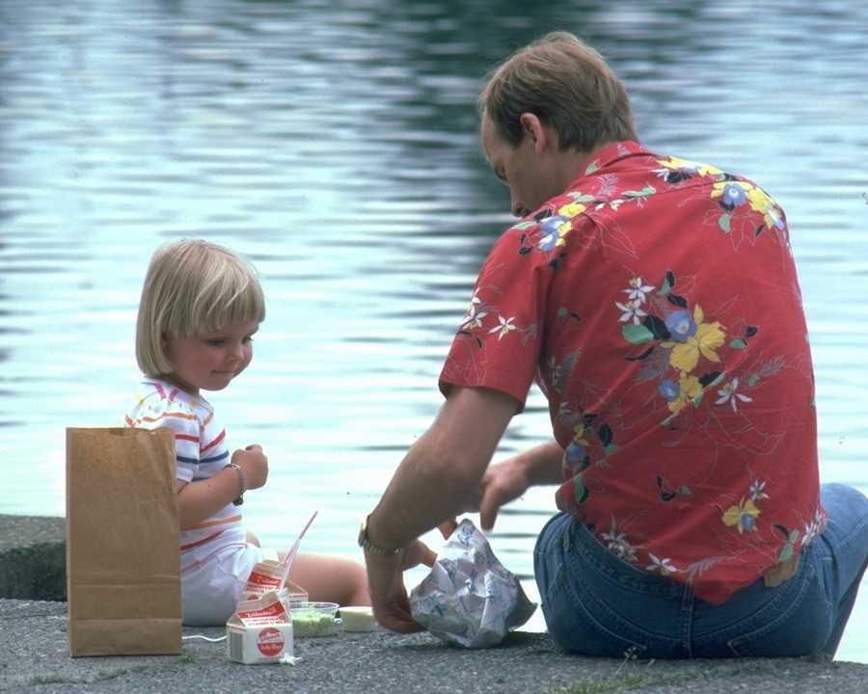

Features of Positive Behavior Interventions and Support

Understanding Patterns

  - Look objectively at behaviors and the circumstances that may prompt the behaviors to occur
  - Act as a detective, looking for clues about the behavior; specifically when, where, with whom and why
  - Pay close attention to interactions with others

Preventing Problems
  - How can environments or situations be changed to make the behavior unnecessary?
  - What can be done ahead of time to decrease stress and increase understanding
  - Consider developing routines

Teaching New Skills
  - What skills does your child need in order to more appropriately get what their needs met?
  - Skills to consider – communicating needs, interaction skills, managing time, calming strategies, problem solving

Responding Effectively

- Consider whether adult reactions contribute to the problem behavior – tone of voice, providing attention, intensity of reaction
- Provide consequences that teach appropriate behaviors rather than simply stop or punish behaviors
- Use punitive consequences such as time-out, restrictions, reprimands sparingly, if at all

Adapted from, ‘Parenting with Positive Behavior Supports.’ Hieneman, Childs, Sergay, 2006

Section 1
The Big Ideas
Setting Up Your Home for Success
Positive Behavior Interventions and Supports
in the Home – The Big Ideas

To use Positive Behavior Interventions and Supports in the home, you must make sure you do the following things:

- Clearly define behavior expectations in a positive way Make sure everyone knows what they are

- Specifically teach and practice the behavior expectations so they become routine

- Closely monitor how well the children are following the expectations


- When appropriate behaviors are observed, specifically acknowledge your child

- When your child engages in behavior errors or misbehavior, correct it using positive language and teaching strategies

- Evaluate strategies for effectiveness and make adjustments if the strategies are not working

If these 6 practices are consistently implemented, your home will run smoother and your children’s behavior will improve. The next pages will assist in developing the 6 Big Ideas of PBIS in your home.
Define Behavior Expectations

Do you know exactly what behavior you expect of your children inside your home? Outside your home? In the community?

Do your children know your expectations of them? How do you know?
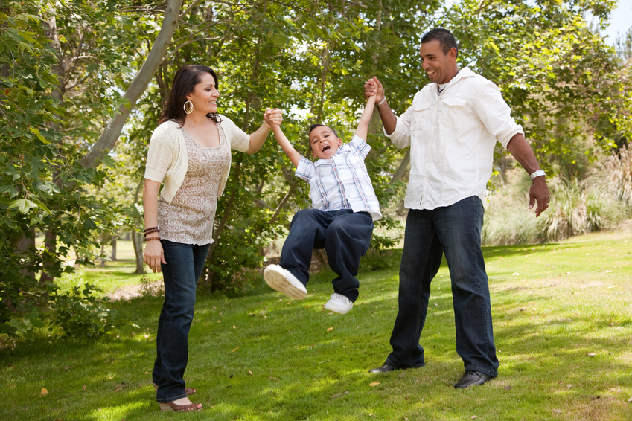

It is very important that adults communicate with each other to send clear, consistent messages to our children about what we expect from them.

*** Clearly defined behavior expectations give children a consistent message about how they are to behave in different situations. ***

What are the behavior expectations at your school? ______________

Note:
There are only 3 to 5 expectations.
They are broad based.
They are positively stated.
They are simple and easy to remember.
Define Behavior Expectations

Typically, behavior expectations address 3 general areas:
- Interactions with others,
- Responsibility,
- Safety
If there are 1 or 2 more specific expectations, they may be added also.

Interacting with Others

Consider the behaviors you would prefer your children use when interacting with others, both adults and children. This is the hard part; think of what you want them to do, not what you don’t want. If you can’t help but think of what you don’t want your children to do, stop and consider the opposite of that behavior. For example; ‘Say positive things to each other’ instead of ‘Don’t call each other names;’ ‘Wait when others are talking,’ instead of ‘Don’t interrupt;’ and ‘Consider others’ feelings;’ instead of ‘Don’t only think about what you want.’

List below, the expected behaviors you have for your child when they are interacting with others:

Is there one simple, broad term that encompasses these behaviors? (Example; Respect Others, Be Kind). What term would you most likely use and your children most understand? List options:

Responsibility
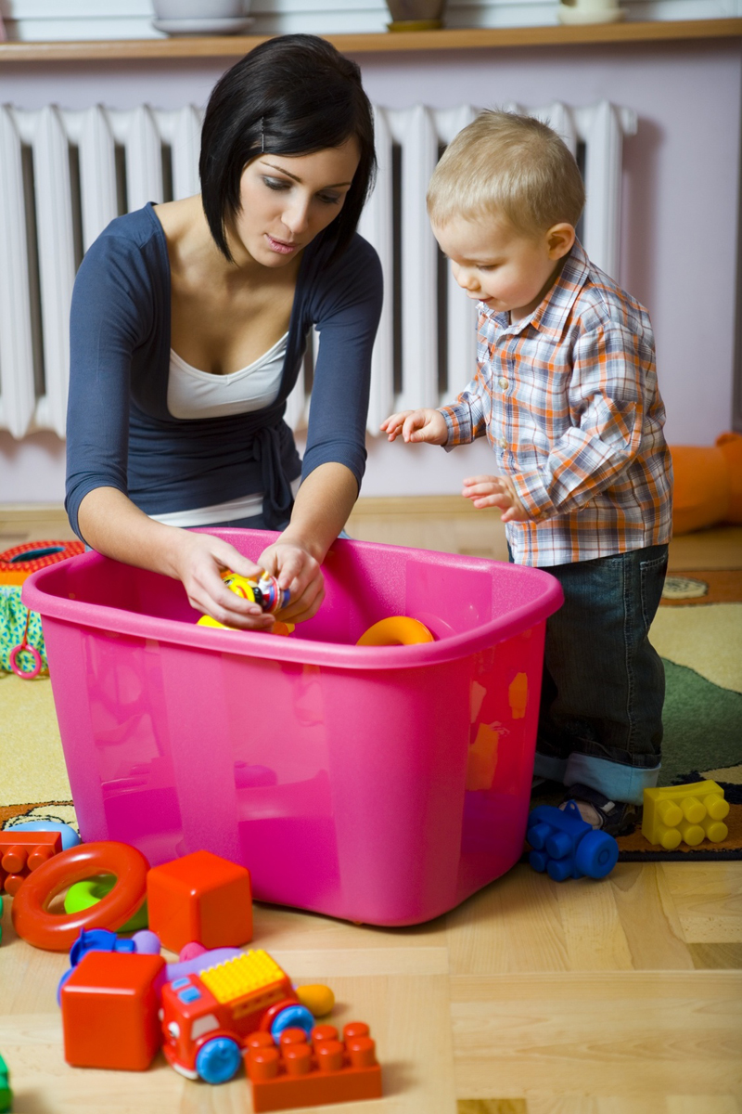
Consider the personal traits that you would like your child to exhibit. What behaviors would help your child to be more happy and successful and help your home to run more smoothly? Remember to think of what you want them to do, not what you don’t want. For example; ‘Pick up after self,’ instead of ‘Don’t be so messy;’ ‘Be on time,’ instead of ‘Don’t be late;’ ‘Tell the truth’ instead of ‘Don’t lie.’

List below the expected behaviors you want for your child regarding important personal traits:

Is there one simple, broad term that encompasses these behaviors? (Example; Be Responsible, Be a Good Person, Be Your Best) What term would you most likely use and your children most understand? List options:

Safety

Consider safe behaviors you want your child to follow. Think of what you want them to do, not what you don’t want. For example; “Use words to solve problems” instead of “Don’t hit your brother;” ‘Stay in the yard’ instead of ‘Don’t go out of the yard;’ and ‘Wear a helmet when you ride your bike’ instead of ‘Don’t ride your bike without a helmet.’

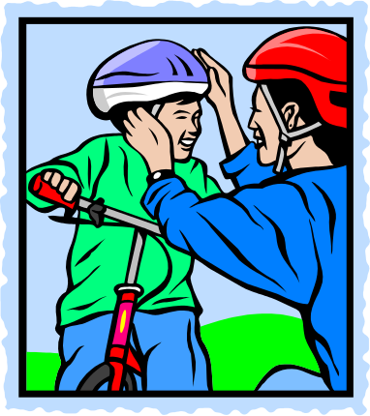
List below the expected behaviors you have for your child regarding Safety:

Is there one simple, broad term that encompasses these behaviors? (Example; Be Safe, Think Safety). What term would you most likely use and your children most understand? List options:

If there are other expectations you have, proceed through this same process with those behaviors.

Define Behavior Expectations

List below, the 3-5 general behavior expectations you have decided to use in your home, for example: ‘Be Safe, Be Respectful and Be Responsible’

1.
2.
3.
4.
5.

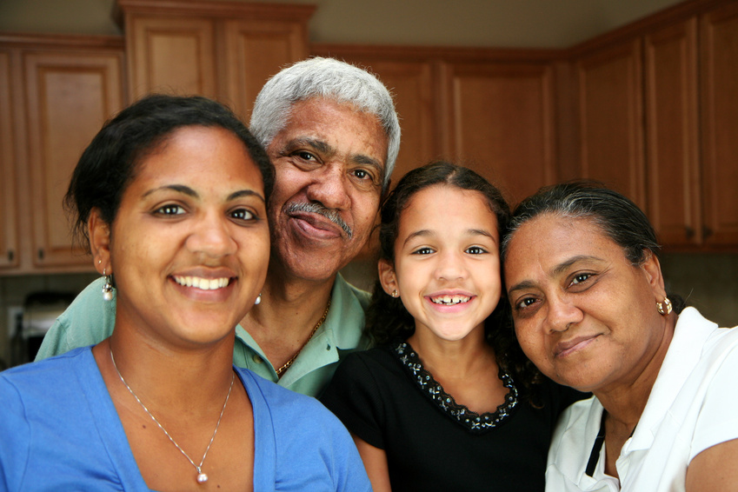
Check to make sure your expectations are:

___ Positively stated
___ Concisely stated
___ Memorable
___ Broad based; general
___ Aligned as much as possible with school’s expectations

Set these expectations to memory, as they will be used many times a day. Share them with anyone else who is with your child for considerable amounts of time. Discuss about how you came up with them and why it is important to you that your child follows these expectations.

The expectations you have created are the foundation for Positive Behavior Interventions and Supports. The interventions and supports you use with your children are built are the expectations!
Matrix and Routines

You may be thinking that telling a child to ‘be safe’ would be very ineffective at raising well behaved children, and you’re right. This is just the beginning!

The expectations are a tool used to prompt, teach, and explain things to children, but these behaviors must be taught!

Quite often, parents assume their children simply know how to behave or know their expectations in specific situations. Sometimes parents think that it is enough to tell their children once, “I want you to be respectful,” and their children will understand what to do. Unfortunately, there are a number of other factors that influence our children and their behavior; temperament, attention span, TV, siblings, peers, video games, and the list goes on.

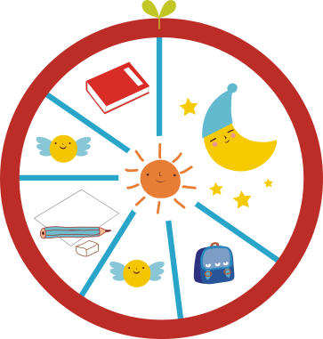
Just as some children know their colors after telling them once, other children have to be taught over and over to recite them correctly. In the same way, some children know the correct behavior after only telling them once while others have to be taught correct behavior over and over to learn.

List below, typical daily activities during the week as well as on the weekends, for example, wake up, eat breakfast, get dressed, get things together for school, ride in the car, playing outside, homework, preparing for dinner…

Consider the expectation regarding safety as it relates to the schedule you listed above. Safety employs different behaviors when riding in the car, as compared to the safety behaviors used when playing outside. These specific behaviors should be identified as illustrated below:

Activities→  Expectations ↓ | Breakfast | Get Dressed | Ride in car | Play outside
Be  Safe | - Eat breakfast slowly  - Sit down to eat  - Fruit, protein, avoid sugar  - Put food away | - Choose clothes for weather  - Tie shoes | - Use seat belt  - Stay seated  - Let driver drive undisturbed | - Keep hands and feet to self  - Stay in the yard  - Ask before using things
Be Responsible | - Rinse dishes when finished  - Put food away  - Clean up messes | - Put pjs away  - Put dirty clothes in hamper  - Dress as quickly as possible | - Pick up and throw out any trash | - Pick up toys  - Come in when called  - Tell if you are going to friends house
Be Respectful | - Say please and thank you  - Use quiet voice  - Eat only your own food | - Follow 5 minute warning | - Use quiet voice when car is moving  - Say please and thank you | - Share toys  - Talk nicely to friends

Tips:

- Think through each setting or routine. What behaviors interfere with it going smoothly? What would you like to happen instead?
- State behaviors positively; in other words list what you want them to do, not what you don’t want
- Be consistent, for instance always list ‘use a quiet voice’ rather than use quiet voice, be quiet, whisper, etc.
- 3-5 behaviors per expectation
- Look through the behaviors you listed on Pages 5-7

Matrix and Routines

Create Routines for Reoccurring Daily Activities

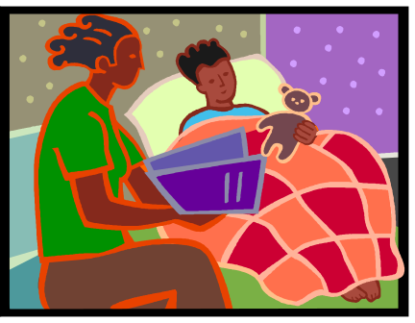
Creating a routine means you do it the same way every time. Children like routines; they are predictable and safe; the child knows what to expect and feels competent.

Developing routines calls for the adults to be consistent and create structure. If this is difficult for you, create checklist for each routine.

Check the activities in which you have established routines and circle those activities which you may want to develop as routines:

 | Morning routine |  | Computer
 | Prep for the bus or car |  | Play time
 | Making bed, picking up room |  | Video game time
 | Taking care of dishes |  | Chores
 | Putting clothes away |  | Taking out garbage
 | Cleaning room |  | Laundry
 | Cleaning house |  | Putting toys away
 | Homework |  | Bath/shower time
 | Dinner prep |  | Getting ready for bed
 | Dinner time |  | Bed Time
 | Clearing table |  | Story Time
 | Washing dishes |  | (other)

Fill in behavior matrix for a typical day. More charts can be found at the back of this book

Activities →

Expectations ↓

Use Visual Supports to Increase Understanding of Routines and Expected Behaviors

As adults, we rely on visual supports everyday. We use calendars, day planners, street signs, grocery lists, maps and so on. Visual cues are used in the work place (directions to use the copy machine) and also on assembly manuals. Using visual cues in our environment allow us to plan, organize and most of all, be independent. Visual supports are equally important to children as they learn new behaviors and routines.

Why use visual supports in your home?



- Words “disappear” right after we say them and visuals hold space and time

- Visuals direct attention to the important things and hold attention

- Visuals allow more time to process the information

- Visuals help us to remember

How to use visual supports for rules:
- Use positive words to state how your child should behave (put toys away)

- Post in a visible area at your child’s eye level

- Refer your child to the posted rules when he is not behaving appropriately

How to use visual supports in general:

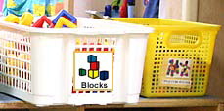
- Use photos, line drawings and sometimes items

- Chore charts

- Labels for putting away toys

- Mini schedules for using the washer machine


- Help manage emotions

- Learn new skills such a washing hands, putting clothes away

Examples of Visual Supports for you to use can be found on Page ____ of the Appendix
Teach and Practice
Behaviors, Expectations, and Routines

If a child doesn’t know how to swim, - we teach,
If a child doesn’t know how to multiply, - we teach,
If a child doesn’t know how to tie his shoes, - we teach,
If a child doesn’t know how to ride a bike, - we teach,

If a child doesn’t know how to behave, we…… punish or teach?

** We must make the last sentence end the same as the first four**

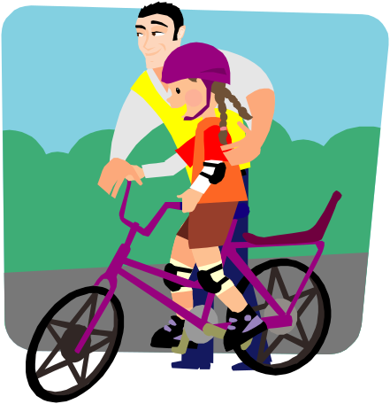
If a child doesn’t know how to behave correctly in a situation, we need to teach them. Teaching a child how to behave is the same as teaching a child how to tie his shoes, ride a bike or multiply.

Teaching behavior involves:

Explaining the Behavior
Modeling the Behavior
Practicing the Behavior
Monitoring the Behavior
Acknowledging Correct Behavior
Correcting Behavior Mistakes

Provide examples of good behavior and specific examples of what you don’t want.

Use the Matrix you created to help drive and organize your teaching.
Teach and Practice
Behaviors, Expectations, and Routines

When teaching and/or reminding about expectations, provide explanations about how engaging in compliant behavior will benefit your children.


“You should keep your room picked up in order to keep your toys from being ruined and so you can find things easier.”

“You want to share with your brother so he will be more likely to share with you when he has something you want.”

“When you wear your seatbelt it keeps you safe, in case there is an accident.”

Children model what we show them. They learn much more from what we do than from what we say. So…

- If you want your child to be respectful to you, be respectful in your interactions with them


- If you want your child to handle frustration well, model a positive way to deal with the frustrating situations they cause you.

- If you want your child to control their anger, show them how to be angry in a productive way

- If you want to avoid power struggles, behave toward them as a teacher not a boss

It Is Better to Build Children Then to Mend Adults
If a child lives with...

-Criticism, a child learns to condemn.
-Hostility, a child learns to fight.
-Fear, a child learns to be apprehensive.
-Pity, a child learns to feel sorry for him or herself.
-Jealousy, a child learns to feel guilty.
-Tolerance, a child learns to be patient.
-Encouragement, a child learns to be confident.
-Praise, a child learns to be appreciative.
-Recognition, a child learns it is good to have a goal.
-Approval, a child learns to like him or herself.
-Honesty, a child learns what truth is.
-Fairness, a child learns justice.
-Acceptance, a child learns to love.
-Security, a child learns to have faith in him or herself

and those about him or her.
-Friendliness, a child learns the world is a nice place in

which to live.
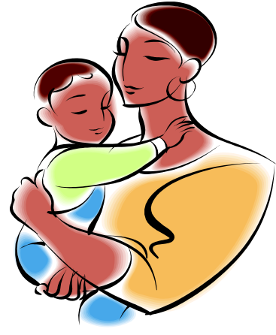

Monitoring Behavior/Expectations
Practice, Practice, Practice!!

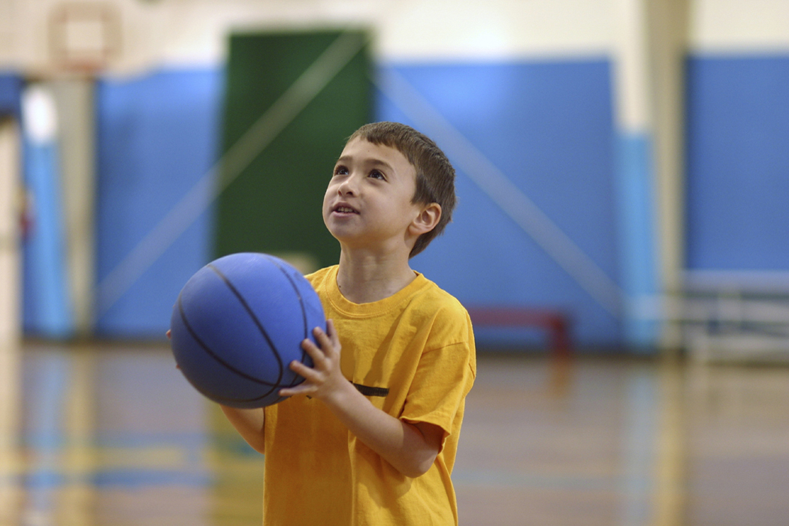
We have children practice dribbling a basketball, playing the piano or riding a bike before assuming they can do it flawlessly on their own. We also want children to practice those behaviors with which they struggle or that they are not quite ‘good enough’ at performing.

Practice provides a perfect opportunity to monitor when and how the behavior errors are occurring. Practice also offers insight into ways to prevent future occurrences of the behavioral error.

*Offer opportunities to practice various behaviors when teaching routines or expectations.

*Make a game of it. When children are in a good mood say, “Let’s pretend you don’t want to go watch the movie I rented and you want to ‘Be Respectful.’ How would you tell me that you are not interested in that movie?

*Role play with children when it really doesn’t matter. When kids are getting and being positive with each other, say, “If you thought she took your favorite top, how could you be safe and let her know it was a problem?”

Watch your children and remind them positively of the expectations when they behave in ways you don’t agree.
Monitor Behavior

Once you have taught various behaviors and routines, watch your children to determine how well they learned them.


- Watch ad listen to what’s going on around you

- Be alert to subtle as well as obvious behaviors, positive or negative

- Subtly check in on your children on a regular basis during non-routines, to make sure they are following your expectations

Why is it so important to monitor behavior?

- It provides opportunities for positive interactions

- It provides your children feedback on how they are doing and keep them on a positive track

- It allows you to reinforce positive behavior

- It helps you notice and deal with negative behavior before it can build

- Kids are less likely to behave when they know a parent might show up at any minute
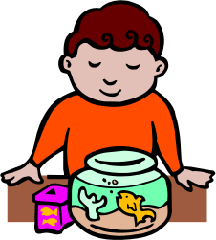
Acknowledge Appropriate Behavior

Catch them being good!!!!

Rule of Thumb: Engage in positive interactions with your children FIVE times as often as you correct them!

It’s the 5:1 Rule

Meaning – find at least 5 opportunities to praise, acknowledge, compliment, thank, hug, smile at, tousle their hair, etc., for every one time you interact with your children to correct a misbehavior.

Positive interactions help to develop trusting, supportive relationships where children feel valued and successful

The key is to look for instances when you child is following your behavior expectations and then let them know you noticed it and to focus on keeping interactions positive.

Praise should include your expectations and be descriptive and genuine. Instead of just saying, “Good Job!” explain what you like and how it benefits them. “Thank you for putting your clothes in the hamper! They’ll get washed much faster now. You are very responsible!”

Remember, acknowledgement is not just telling your children positive things about behavior, it is also spending positive, quality time together and letting them know how much you enjoy them and how much they mean to you.
Acknowledge Appropriate Behavior

Different Types of Acknowledgement

Social Acknowledgement

- Praise – praising appropriate behavior, following expectations/routines. Be specific about the behavior you are praising and why it is beneficial for your child to do it. Include your expectations if possible. Monitor your tone of voice. Avoid sarcasm or frustration. Be genuine.

- Physical Contact – pats on the back, tickling, romping, hand on the shoulder, hugs

- Activities – engaging in activities selected by the child. You may want to comment on having more time to do ____, because your child ______.

- Grandma’s Rule – When you do _____, you can ____. ‘When you finis picking up your toys, you can go outside.’

Non Social Acknowledgement (must always be combined with social acknowledgement)


- Stickers

- Star Charts

- Favorite Foods

- Favorite Toys

Always tell your child what you appreciate that they did,
not what they didn’t do.
Correct Behavior Errors

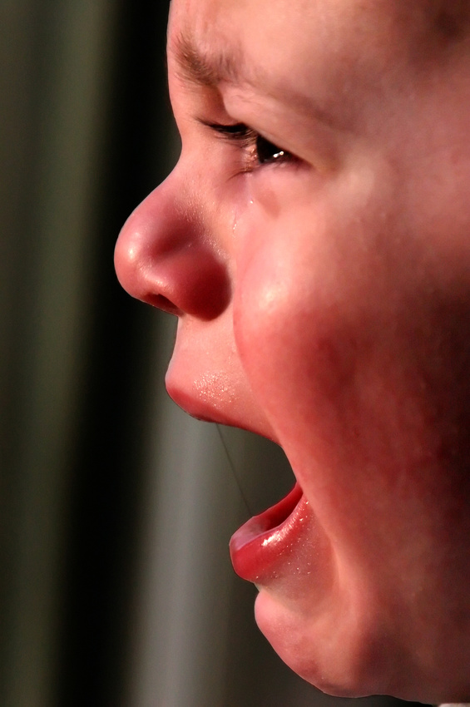
When your child does not behave in the manner you think they should, the way you view that misbehavior plays a large role in how effective your intervention will be.

How do you view your child’s misbehavior?

- When your son or daughter walks in the room crying loudly for the third time today, which of the following thoughts are you more likely to have?

- ‘Bobby’ seems upset again, I need to figure out how to calm him down and help him have more self control.’
- ‘Oh my gosh, again? ‘Bobby is being such a baby today! He has to stop or he’ll drive me crazy.’

  - When your son or daughter responds to you in a “snotty” tone, which thought are you more likely to have?

    - ‘She can’t possibly think she is going to get away with talking to me in that tone! If I hear that tone one more time, she’s grounded for a week!’
    - ‘Am I speaking to her in a disrespectful tone? I need to model respect in my tone so she understands how to talk to people with respect even when upset. We will have to talk about this later and review respectful tones of voice, but now is not the time.’

- When you hear your son or daughter swear, which thoughts are you more likely to have?

- ‘He has developed the filthiest mouth ever! I’ll teach him not to do it by washing his mouth out with soap!’
- ‘He doesn’t understand when it is appropriate and when it is not appropriate to say those words. I hope I am not inadvertently modeling it for him. I need to address more respectful behavior with him.’
Correct Behavior Errors

Reframing Your Thoughts

The exercise on the previous page may have left you thinking, ‘But I can’t control how I view my child’s behavior any more than I can control the weather!’ The truth is you can start being aware of your thoughts and reframing them in order to be more positive and effective.

- First, begin being aware of how your view your child’s misbehavior.

- Do you see your son or daughter’s misbehavior as all their fault; as some problem or issue with their personality?

- Begin to view your children’s behavior as something you teach, model, practice with them.

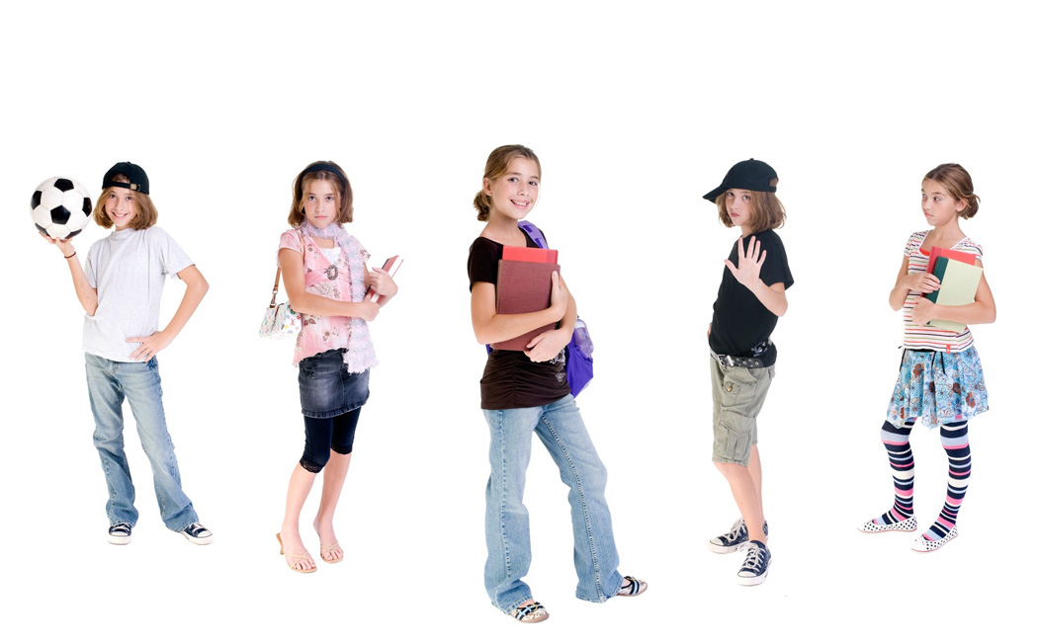
- Understand that all children are different. Just as some children have a hard time learning to read, others have a more difficult time learning to behave. It is our job as parents, teachers, grandparents, childcare workers to help them understand correct behavior.

- Realize that when you do not want your child to engage in their problem behaviors, you can do something other than punish them. You can teach them in a calm, respectful fashion.

Reframing your thoughts will take some time, just as teaching your children takes time. Be patient with yourself and with them.
Correct Behavior Errors

NOTE: All behaviors meet needs

- Needs are not good or bad, they just are

- Teach your children a better way to have their needs met

- Always include your expectations when talking about how to meet your child’s needs

NEEDS of Behavior: When considering what needs your child’s behavior are meeting, understand that there are 2 broad based needs that every behavior meets:

Getting something you want
Getting away from something you don’t want

Getting Something You Want |  | Getting Away from Something You Don’t Want
*Someone’s attention (Mom, when she’s on the phone) |  | *Someone’s attention (someone  giving directions)
*An activity (TV, cooking, etc.) |  | *An activity (homework, chores etc.)
*An item (candy, a toy, etc.) |  | *An item (smelly socks, dirty dishes)
*Sensory (music, lights, touch) |  | *Sensory (music, pain, lights)

This applies to every human on earth – you included!
Correct Behavior Errors

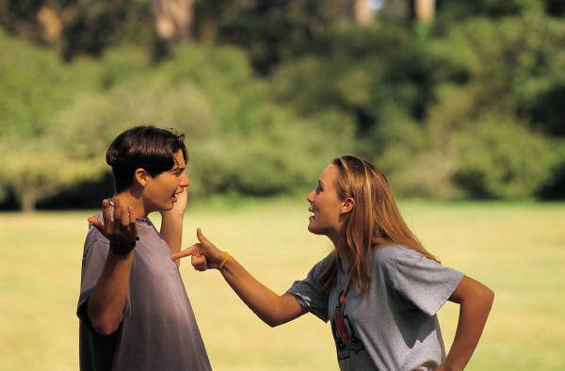
When considering ways to correct behavior, many move directly to punishing consequences such as time out, withholding desired items or activities, or physical punishment. Most likely, this is due to social history and experience. It is very important to remember that…

**Punishment serves only to INTERRUPT behavior,
NOT CHANGE or improve behavior**

***Teaching; practice; monitoring; building positive, trusting relationships; developing routines; and putting focus on positive behavior actually changes behavior ***

If you find the need to use negative consequences, keep the following in mind:

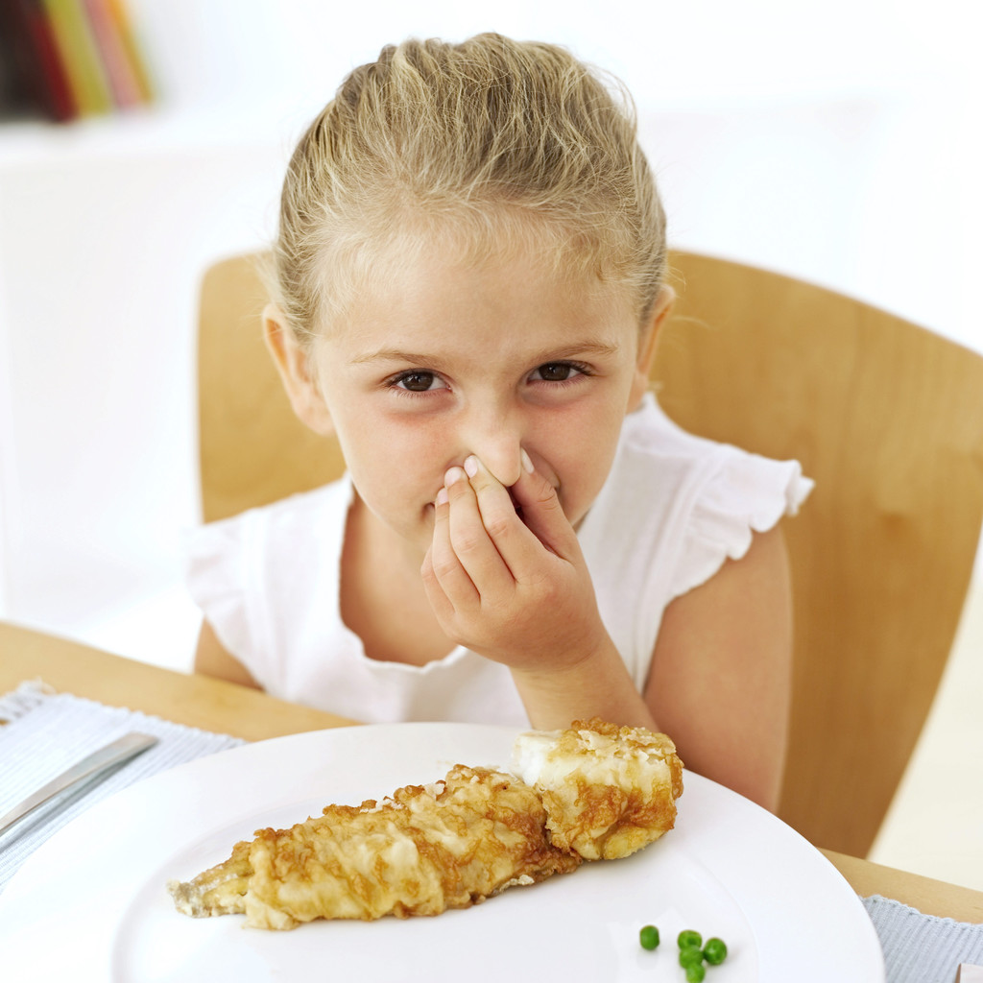
- Choose a “common sense consequence” that is related to the behavior. Time out, grounding and taking away privileges may not be related to the misbehavior. If your child interrupts, doesn’t do their chores, or won’t eat their dinner, taking the TV away has no relation to that behavior. Using a consequence that is unrelated to the behavior often causes power struggles.

- Prepare your child for the consequence. Give fair warning of what will happen, but do it only once. Be respectful in tone and words when explaining what you have decided to do. DO NOT NAG.

- Follow through with your consequences. Do what you said you were going to do. This is not the time for reminders or second chances. Chances teach children not to listen to us the first, second, or even third time!

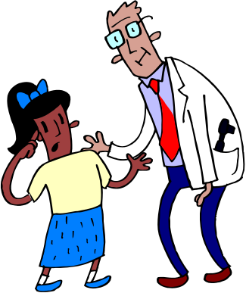
- Take action instead of justifying and/or explaining. Following through with parenting consequences doesn’t require talk. It is much more effective for parents to let their actions do the talking. Parents may feel the need to explain or justify with carrying out a consequence by saying, “I told you I was going to ________ if you _____.” Or “If you had only ______ like I asked, you wouldn’t have to ________.”

Take action by following through with the consequence, no explanations needed. Actions speak louder than words.
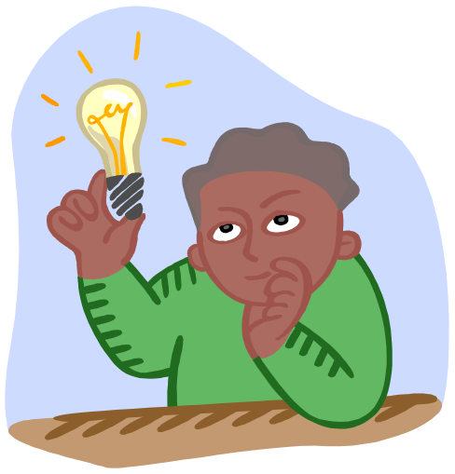
- Evaluate Be open to making small changes after you have experimented with something for at least a month. If you have tried something consistently and it isn’t working after one month, don’t hesitate to alter it or try something new.

- Use statements that are enforceable. Parents become less effective if they make statements the child knows can’t be done

Enforceable |  | Not Enforceable
- I will listen to you when your voice matches mine.  - I look forward to hearing you when I am finished with this phone call.  - You are welcome to use this toy when you play nicely with these toys  - You may play with the children when you use kind words  - When you demonstrate that you can follow my expectations, you may use the car again. |  | - Don’t talk to me in that tone.  - Keep interrupting me and there is no TV for a year!  - You will never be able to play with this again!  - Be nice!  - You do that again and you will be grounded for life!

- Tone of voice. The tone of voice used should always be respectful and calm, after all, you are the adult and the one in charge. Sarcasm, disrespect, anger and frustration come through loud and clear by one’s tone of voice. People of all ages respond more to the tone of someone’s voice than to the words said. This is particularly so when being corrected or given a negative consequence. At all costs, try to be calm and respectful when interacting with your children.

CONSEQUENCES THAT TEACH

Helpful Consequences Should:

- Decrease the efficiency of the behavior while maintaining dignity and an atmosphere of caring,

- Never degrade or humiliate,

- Logically relate to the target behavior,

- Do not cause more of a problem than the problem they are addressing,

- Establishes conditions for learning alternative skills,

- Decreases the frequency, duration, and/or intensity of the target behaviors,

- Be individualized for each child in order to be effective,

- Teach involve processing,

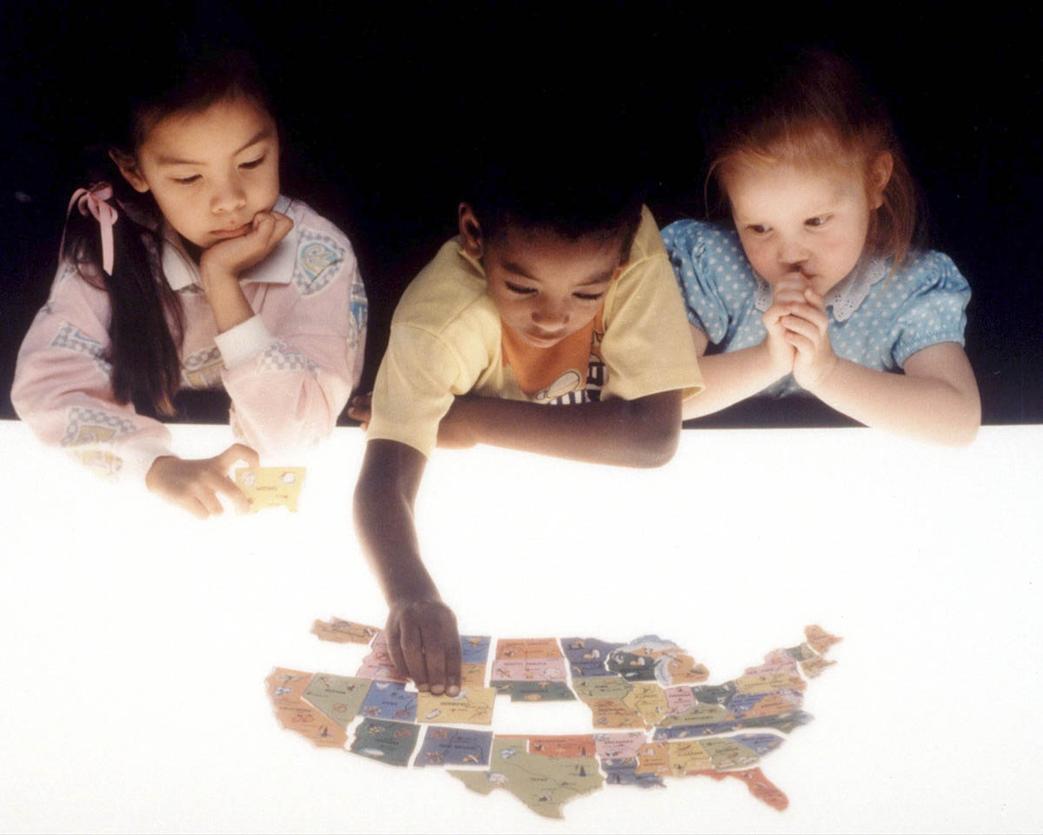
- Involve restoring the environment back to how it was before the problem

- Be supportive, and

- Be designed to teach, not hurt.

Problems with Punishment

- Punishment focuses on external control but does little to teach internal control.
- Punishment does not teach the child how to meet needs previously being served by the undesired behavior.
- Punishment backfires with children who are oppositional and defiant.
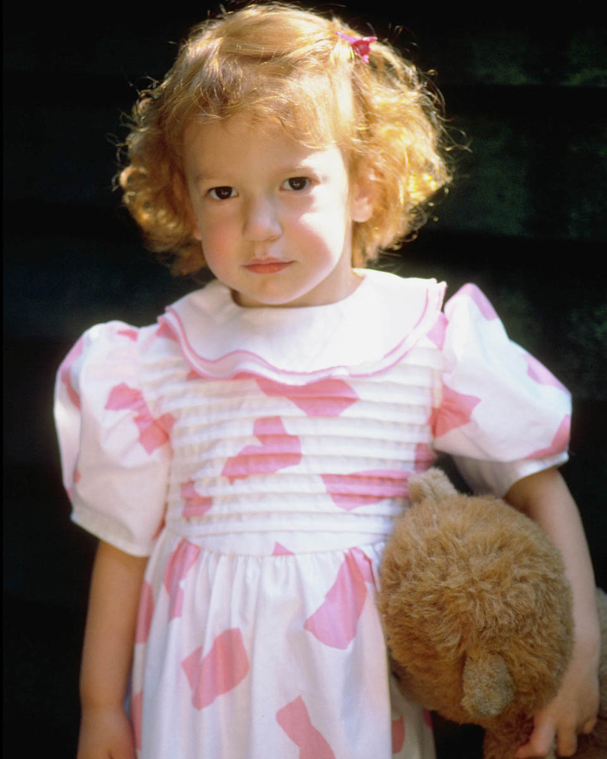
- Punishment often triggers an escalation of behavior and may elicit tantrums and aggression.
- Punishment models a type of authority that resolves conflict by power and inflicting discomfort or pain.
- Punishment is a quick-term fix that takes much less time than to teach the child betters ways of behaving.
- Research has shown that punishment strategies have poor transferability.
- Punishment is inconsistent with the concept of mutual respect.
- Punishment often excludes and isolates a child when teaching and support is needed most.

Things to Do Instead of Spanking
By Kathryn Kvols

Research confirms what many parents instinctively feel when they don’t like to spank their child, but don’t know what else to do. The latest research from Dr. Murray Strauss at the Family Research Laboratory affirms that spanking teaches children to use acts of aggression and violence to solve their problems. It only teaches and perpetuates more violence, the very thing our society is so concerned about. Research further shows that children who have been spanked are more prone to low self-esteem, depression and accept lower paying jobs as adults. So, what do you do instead?


- Get Calm – First, if you feel angry and out of control and you want to spank or slap your child, leave the situation if you can. Calm down and get quiet. In that quiet time you will often find an alternative or solution to the problem. Sometimes parents lose it because they are under a lot of stress. Dinner is boiling over, the kids are fighting, the phone is ringing and your child drops the can of peas and you lose it. If you can’t leave the situation, mentally step back and count to ten.


- Take Time for Yourself – Parents are more prone to use spanking when they haven’t’ had any time to themselves and they feel depleted and hurried. So it is important for parents to take some time for themselves to exercise, read, take a walk or pray.

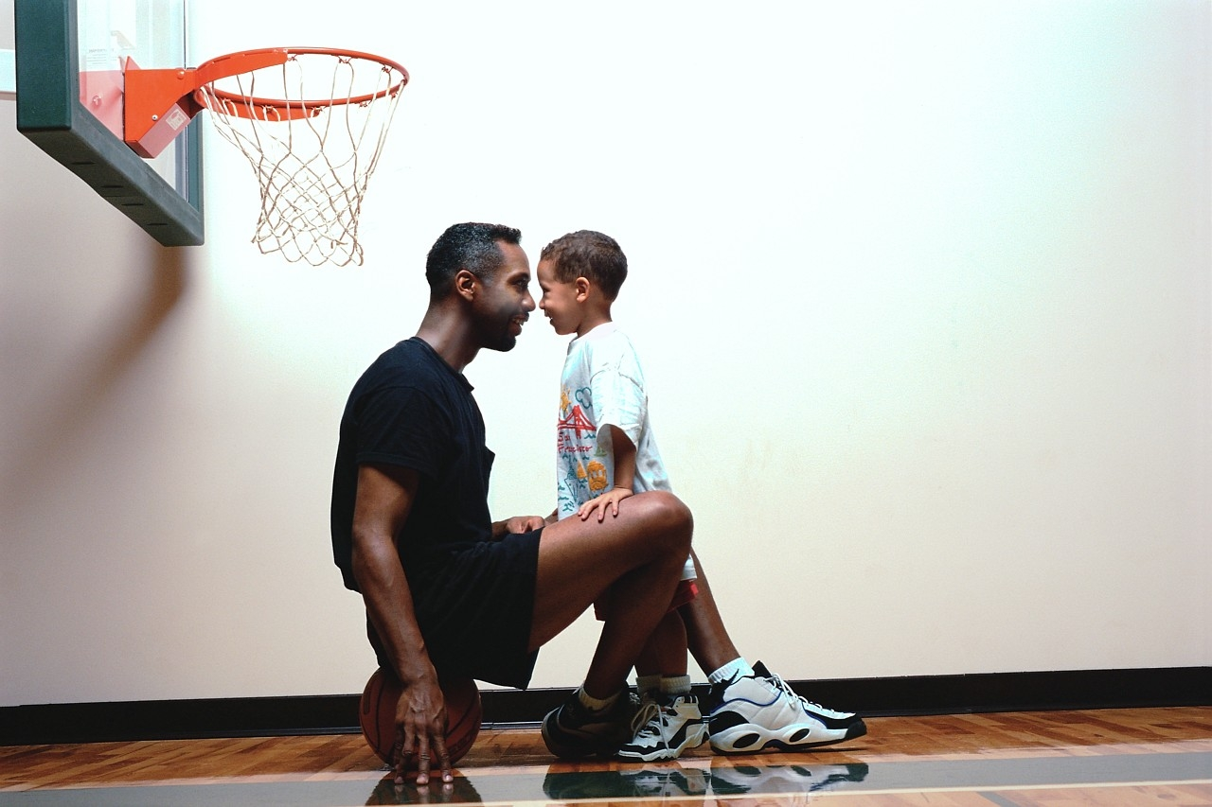
- Be Kind but Firm – Another frustrating situation where parents tend to spank is when your child hasn’t listened to your repeated requests to behave. Finally, you spank to get your child to act appropriately. Another solution in these situations is to get down on your child’s level, make eye contact, touch him gently and tell him, in a short, kind but firm phrase, what it is you want him to do. For example, “I want you to play quietly.”

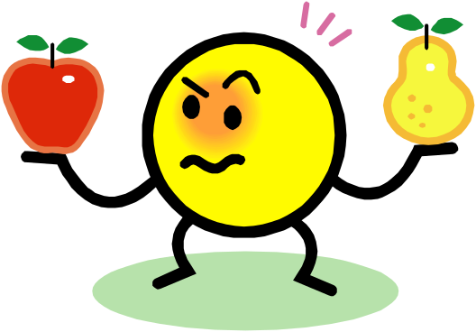
- Give Choices – Giving your child a choice is an effective alternative to spanking. If she is playing with her food at the table say, “You can either stop playing with your food or you can leave the table.” If the child continues to play with her food, use kind but firm action by helping her down from the table. Then tell her that she can return to the table when she is ready to eat her food without playing in it.

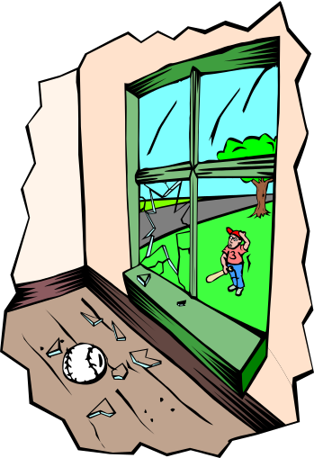
- Use Logical Consequences – Consequences that are logically related to the behavior help teach children responsibility. For example, your child breaks a neighbor’s window and you spank him. What does he learn from this situation? He may learn not to do that again, but he also learns to hide his mistakes, blame them on someone else, lie or simply not get caught. He may decide that he is bad or feels anger and revenge toward the parent who spanked him. When you spank a child, he may behave because he is afraid to get hit again, however, do you want your child to behave because he is afraid of you or because he knows better than to misbehave? Compare this situation with a child who breaks a window and his parent’s say, “I see you’ve broken the window, what will you do to repair it?” using a firm but kind voice. The child decides to mow the neighbor’s lawn and wash his car several times to repay the cost of breaking the window. What does the child learn in this situation? That mistakes are an inevitable part of life and it isn’t so important that he made the mistake but that he takes responsibility to repair the mistake. The focus is taken off the anger or revenge toward his parent.

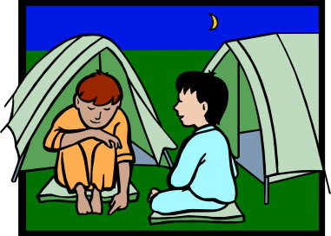
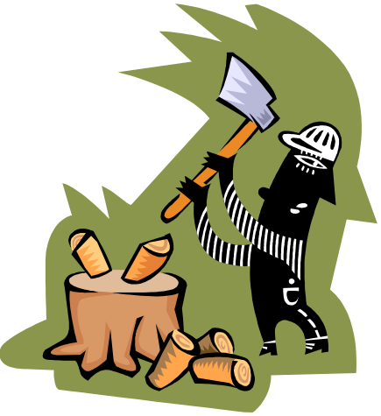
- Do Make Ups –When children break agreements, parents tend to want to punish them. An alternative is to have your child do a make-up. A make-up is something that people do to put themselves back into integrity with the person they broke the agreement with. For example, several boys were at a sleepover at Larry’s home. His father requested that they not leave the house after midnight. The boys broke their agreement. The father was angry and punished them by telling them they couldn’t have a sleepover for two months. Larry and his friends became angry, sullen and uncooperative as a result of the punishment. The father realized what he had done. He apologized for punishing them and told them how betrayed he felt and discussed the importance of keeping their word. He then asked the boys for a make-up. They decided to cut the lumber that the father needed to have cut in their backyard. The boys became exited and enthusiastic about he project and later kept their word on future sleepovers.

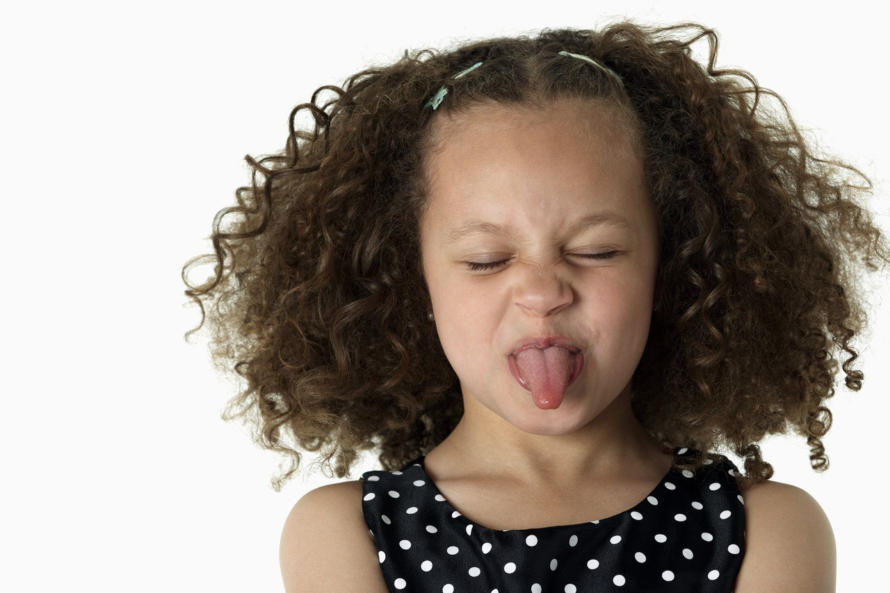
- Withdraw from Conflict – Children who sass back at parent may provoke a parent to slap. In this situation, it is best if you withdraw from the situation immediately. Do not leave the room in anger or defeat. Calmly say, “I’ll be in the next room when you want to talk more respectfully.

- Use Kind but Firm Action – Instead of smacking an infant’s hand or bottom when she touches something she isn’t supposed to, kindly but firmly pick her up and take her to the next room. Offer her a toy or another item to distract her and say, “You can try again later.” You may have to take her out several times if she is persistent.

- Inform Children Ahead of Time – A child’s temper tantrum can easily set a parent off. Children frequently throw tantrums when they feel uninformed or powerless in a situation. Instead of telling your child he has to leave his friend’s house at a moment’s notice, tell him that you will be leaving in five minutes. This allows the child to complete what he was in the process of doing.

- Understand How Spanking Models Aggression - Aggression is an obvious form of perpetuating violence in society. A more subtle form of this is spanking because it takes it’s toll on a child’s self-esteem, dampening his enthusiasm and causing him to be rebellious and uncooperative. Consider for a moment the vision of a family that knows how to win, cooperate and creatively solve their problems without using force or violence. The alternatives are limitless and the results are calmer parents who feel more supported.

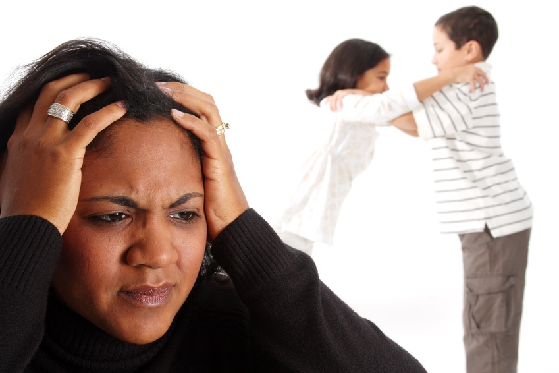

Section 2
Suggestions, Strategies and Ideas
Keys to Successful Parenting
Positive Parenting.com

It is important that we discipline in a way that teaches responsibility by motivating our children internally, to build their self-esteem and make them feel loved. If our children are disciplined in this respect, they will not have a need to turn to gangs, drugs, or sex to feel powerful or belong.

The following ten keys will help parents use methods that have been proven to provide children with a sense of well-being and security.


- Use Genuine Encounter Moments (GEMS) – Your child’s self-esteem is greatly influenced by the quality of time you spend with him, not the amount of time. With busy lives, we are often thinking about the next thing that we have to do, instead of putting 100% focused attention on what our child is saying to us. We often pretend to listen or ignore our child’s attempts to communicate with us. If we don’t give our child GEMS throughout the day, he will often start to misbehave. Negative attention in a child’s mind is better than being ignored.
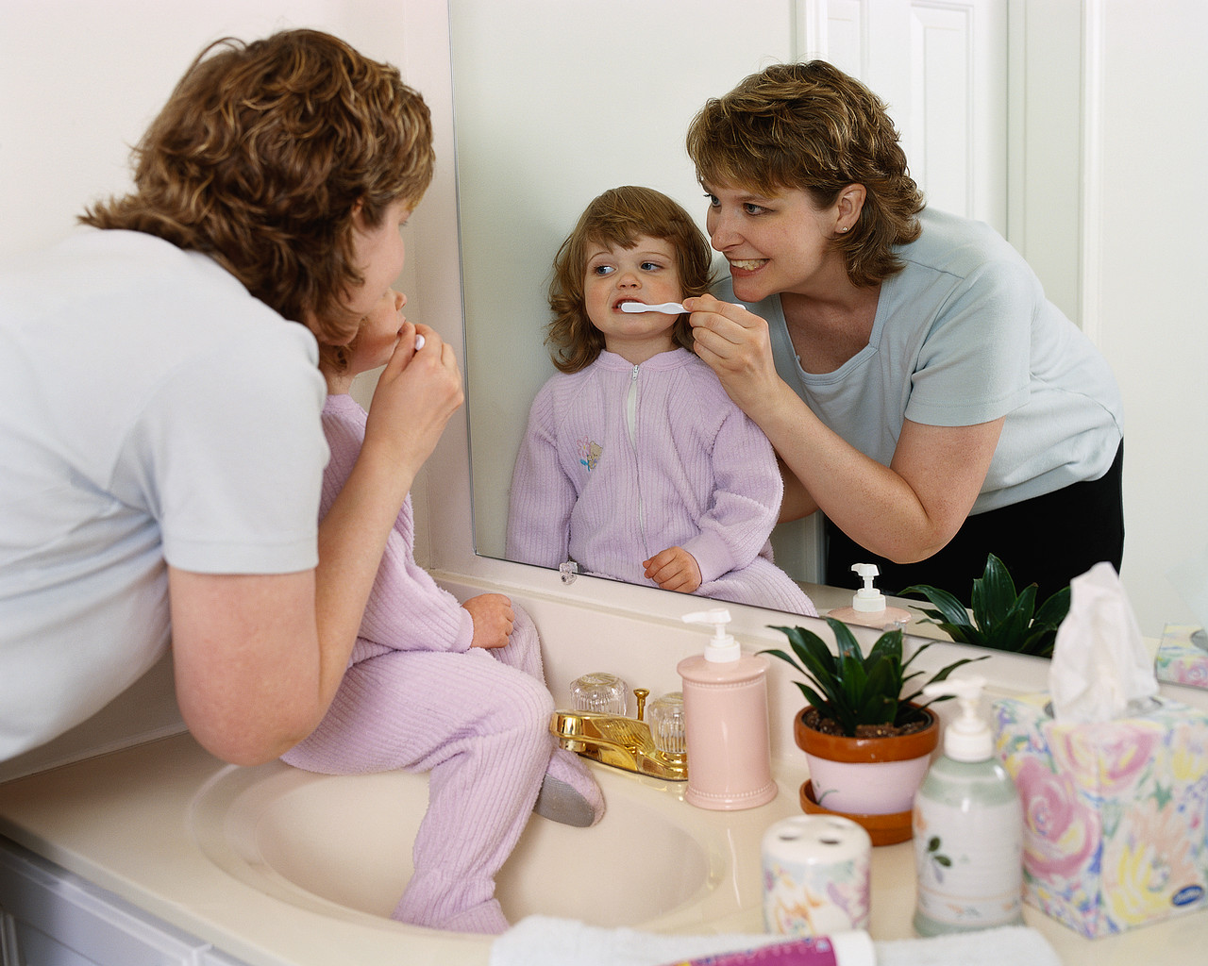
It is also important to recognize that feelings are neither right nor wrong. They just are. So when your child says, “Mommy, you never spend time with me,” (even though you just played with her) she is expressing what she feels. It is best at these times to just validate her feelings by saying, “Yeah, I bet it does feel like a long time since we spent time together.”

- Use Action, Not Words – Statistics say that we give our children over 2000 compliance requests a day! No wonder our children become “parent deaf.” Instead of nagging or yelling, ask yourself, “What action could I take?” For example, if you have nagged your child about unrolling his socks when he takes them off, only wash socks that are unrolled. Action speaks louder than words.


- Give Children Appropriate Ways to Feel Powerful – If you don’t, they will find inappropriate ways to feel their power. Ways to help them feel powerful and valuable are to ask their advice, give them choices, and let them help you balance your checkbook, cook all or part of a meal, or help you shop. A two-year-old can wash plastic dishes, wash vegetables, or put silverware away. Often we do the job for them because we can do it with less hassle, but the result is that they feel unimportant.


- Use Natural Consequences – Ask yourself what would happen if I didn’t interfere in this situation? If we interfere when we don’t need to, we rob children of the chance to learn from the consequences of their actions. By allowing consequences to do the talking, we avoid disturbing our relationships by nagging or reminding too much. For example, if your child forgets her lunch, and you don’t bring it to her, you allow her to find a solution on her own and learn the importance of remembering.

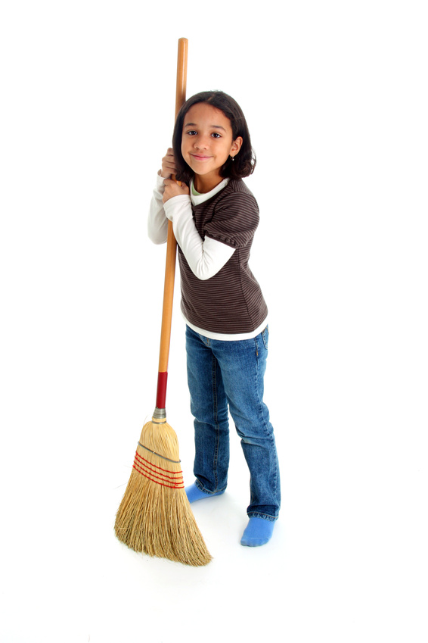
- Use Logical Consequences – Often the consequences are too far in the future to practically use a natural consequence. When that is the case, logical consequences are effective. A consequence for the child must be logically related to the behavior in order for it to work. For example, if your child forgets to return his video and you ground him for a week, that punishment will only create resentment within your child. However, if you return the video for him and either deduct the amount from his allowance or allow him to work off the money owed, and then your child can see the logic to your discipline.

- Withdraw from Conflict – If your child is testing you through a temper tantrum, power struggle, or being angry or speaking disrespectfully to you. It is best if you leave the room or tell the child you will be in the next room if he wants to “Try again.” Do not leave in anger or defeat.

- Separate the Deed from the Doer – Never tell a child that he is bad. Help your child recognize that it isn’t that you don’t like him, but it is his behavior that you are unwilling to tolerate. In order for a child to have healthy self-esteem, he must know that he is loved unconditionally no matter what he does. Do not motivate your child by withdrawing your love from him. When in doubt, ask yourself, did my discipline build my child’s self-esteem and thereby his character?

- Be Kind and Firm at the Same Time – Suppose you have told your five-year-old child that if she isn’t dressed by the time the timer goes off, you will pick her up and take her to the car. She has been told she can get dressed either in the car or at school. Make sure that you are loving when you pick her up; yet firm by picking up as soon as the timer goes off without any more discussion. If in doubt, ask yourself, did I motivate through love or fear?


- Parent with the End in Mind – Most of us parent with the mindset to get the situation under control as soon as possible. We are looking for the expedient solution. This often results in children who feel overpowered. But if we parent in a way that keeps in mind how we want our child to be as an adult, we will be more thoughtful n the way we parent. For example, if we spank our child, he will learn to use acts of aggression or intimidation to get what he wants when he grows up.

- Be Consistent, Follow Through – If you have made an agreement that your child cannot buy candy when she gets to the store, don’t give in to her pleas, tears, demands or pouting. Your child will learn to respect you more if you mean what you say.

Ways to Make Waiting Fun

- Ask your child to make up a silly, outrageous story about why the waitress is taking so long to deliver the meal, or what caused the traffic jam.

- Hold up an ordinary item such as a pencil or spoon. Have the child suggest unusual uses for the object.

- Take turns singing as many songs as you know that have a color in the song. Example: Rudolf the RED Nosed Reindeer, The YELLOW Rose of Texas, BLUE Suede Shoes, etc.

- Ask your child to close their eyes and describe what you are wearing.
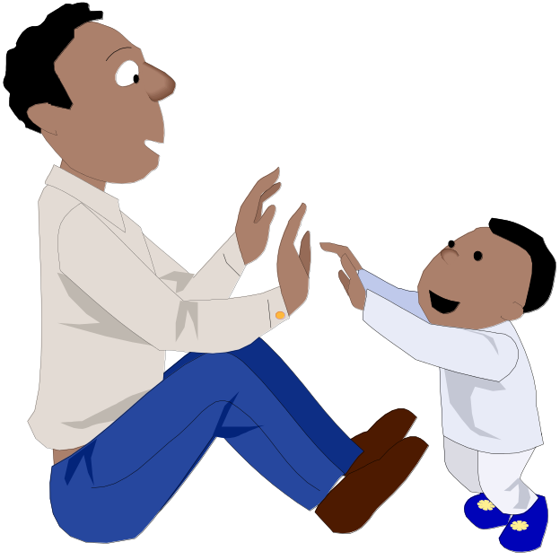
- Ask your child to list 10 things found in a dentist office, car repair shop, or bakery.

- Thumb wrestle with your child.

- Hum a song and have your child guess the title.

- Give your child the name of a character in a book. They have to identify the book title.

- Tell your child three unrelated items such as, a dirty sock, watermelon and a swing set. Ask them to tell you a story incorporating those items.

Doing Homework

- Set aside a time each day for homework
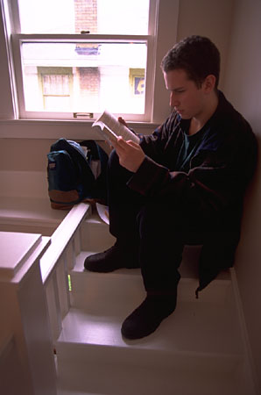
- Parents decide homework time with their children. While children are in the lower grades, one hour a day should be enough. As homework and responsibilities increase, more time will be needed
- Start early. Although it is not recommended to begin formally teaching children before they start school, parents can begin to set a good example for their children long before they start school.
- Provide a quiet, comfortable study area. It's a good idea that studying be done in the same place every day. Parents should make sure their children have the supplies they need (for example, paper, pencils, a pencil sharpener). Children's bedrooms have numerous distractions and are not always the best place to study.
- Provide reinforcement. Praise your children for working hard and completing assignments. Keep in mind, though, that homework is not always fun. Don't expect perfection.
- Offer help. Be available to answer questions that might come up. Try to provide information without actually doing the homework.
- Give children the responsibility for their own homework. Parents cannot force their children to study. Nagging and threatening don't work. Children need to know that they are responsible for doing their homework and for studying.

Respecting Adults

- Teaching respect is often learned best as a modeled behavior. Children learn respectful behavior from watching their parents interact with other adults.

- Children who are treated with respect are more respectful of others.

- Children tend to pick up prejudices and stereotypes from their elders (e.g., hearing negative comments about police, teachers, principals, mentally handicapped individuals, over weight individuals, minorities, etc.)

- Limit exposure to media that models disrespect (e.g., Professional Wrestling, Family Guy, South Park, vulgar music, etc.)

- Teach children how to respectfully resolve conflicts even when they disagree.

- Teach children to respect others who they deem as weaker or different.

- Consequate disrespect by processing respectfully.

- Teach boys that a “real man” would never hit a woman.
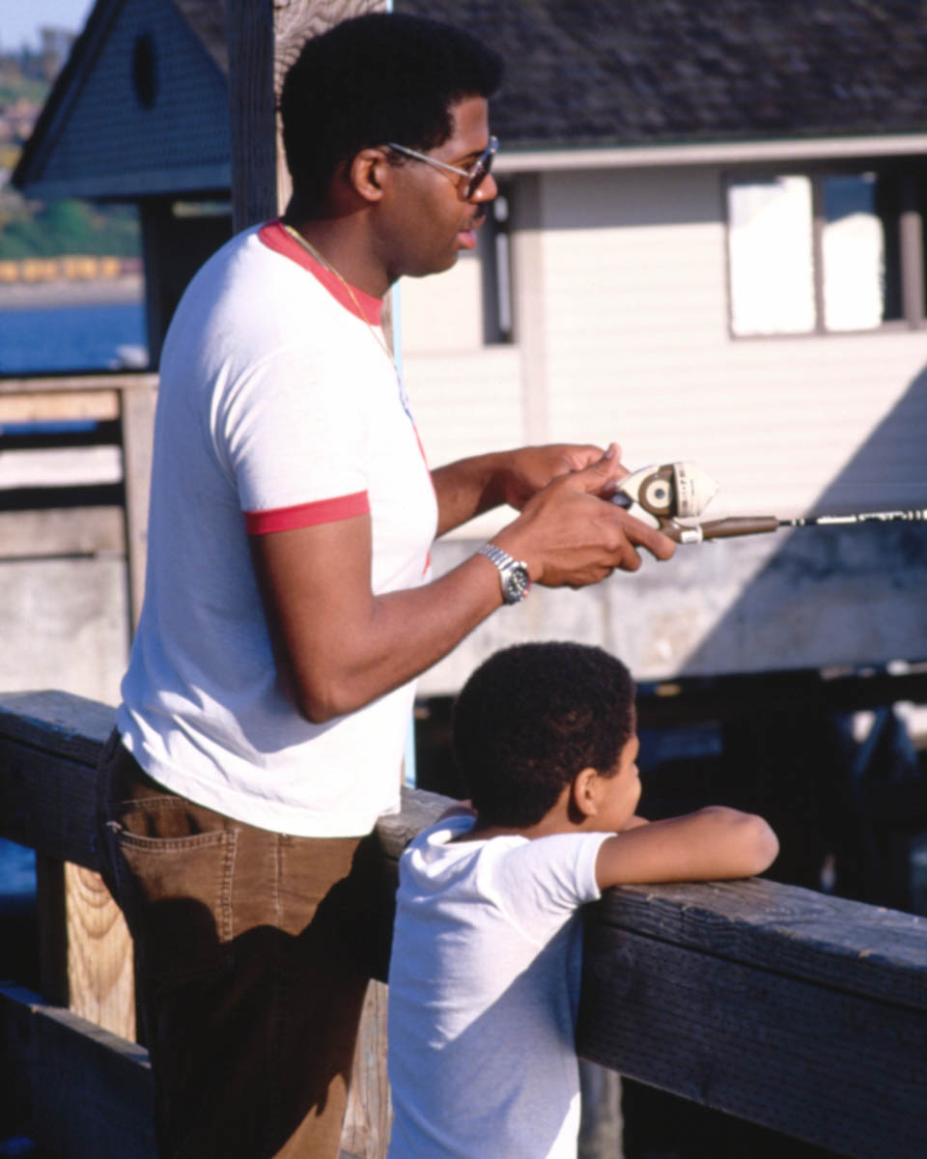
Controlling Temper and Anger

- Teach and model for the child appropriate ways to deal with anger.

- Provide a plan to use when the child is angry.

- Learn diffusion and de-escalation strategies (e.g., personal space,
allow venting, avoiding ultimatums, staying calm, etc.)

- Provide a safe place for the child to go when the child is angry.

- Do not argue or interact with the child when he is out of control.

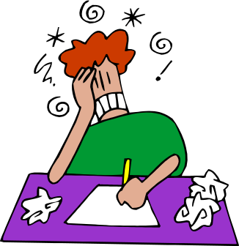
- Do not respond to disrespectful things child says in anger.

- Do not confront or threaten a child who is loosing control.

- Calmly set concise, reasonable, enforceable limits (i.e., let the child know the consequences of his/her choices).

- Understand the stages of anger (i.e., anxiety, defensive, acting out, tension reduction)

- Practice verbal de-escalation strategies (empathic listening, neutral statements, reflection, negotiation, etc.)

- When you feel yourself loosing control, walk away until you are calm enough to model appropriate conflict resolution.

- If you have lost control, apologize to the child and acknowledge that you will try to respond differently in the future.

- Re-connect with your child as soon as possible in a positive way.

Teaching Responsibility

- Have family meetings to discuss responsibilities

- Provide incentives and praise for responsible behavior

- Model responsible behavior (e.g., meet commitments, honor deadlines, be punctual and dependable, etc.)

- Teach children why responsibility is important

- Provide logical but restorative consequences for irresponsible behavior

- Provide a way for the child to redeem him/herself

- Increase trust and responsibility as the child grows older

- Emphasize self control and making good choices

- Empower the child to be responsible for his own actions

- Help the child when he/she is in over her head

- Use logical consequences that relate to the behavior

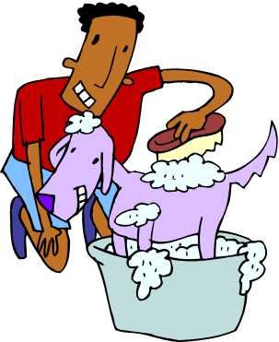

Different Ways To Say "No"
- That’s not an option right now.
- Say it in a funny way, i.e. "Never in a million, trillion years!"
- That’s not appropriate.
- I am not ready for you to do that yet. (Great for teens)
- For a younger child, distract them with something off the topic.
- Ask, "What do you think you would need to do before I would be willing to say yes to that?"
- Ask, "What do you think? Is this a good choice for you?" (If you choose this, make sure you are willing to abide by her answer)
- For a youngster that has something you don’t want him to have, say, "That’s not a toy."
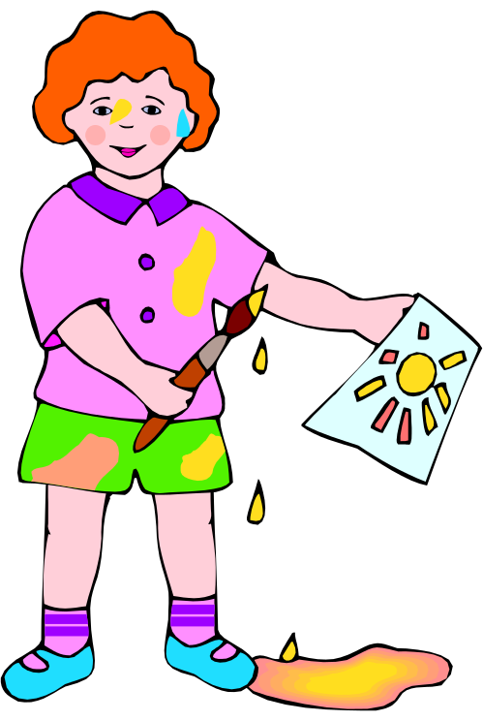
- Ask, "What are your other options?"
- No, but I would be willing to...
- I appreciate your asking, however...
- Walls are not for coloring. Here is a piece of paper.
- Tell them what to do instead i.e., "Water needs to stay in the tub."
- This is not negotiable.
- Later (but honor this).
- “After you pick up your toys”
- Explain why. Process.
- Problem solve about how to get to “yes.”

Section 3
Handling Specific Problem Behaviors

WHEN IS BEHAVIOR A PROBLEM?

- At home, a child’s behavior is a problem if it continuously works against the spirit of community and caring that has been established within the family unit,

- At school, child’s behavior is a “problem” if it interferes with learning, interferes with teaching, or has the potential to cause harm to self, others, animals, or property,

- Even though a child’s behavior presents a problem for us, it is the most efficient way that child knows how to meet a particular need.

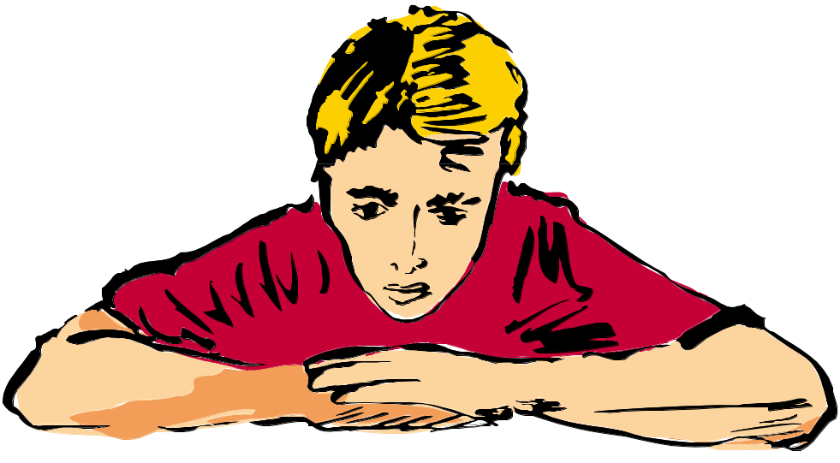

Taking a Broader Look at Specific Problem Behaviors

For persistent behavior issues at home, it is recommended that a plan be created (Worksheet on page 43). The plan should always include the following components:


- Define the behavior in a objective way that can be observed (i.e., hitting as opposed to being mean).

- Prevention: What will you and other adults do to prevent the likelihood of the behavior occurring again?

- Replacement Behaviors: What do you want the child to instead of the problem behavior? (i.e., keep hands to self and use problem solving skills as opposed to stop hitting).

- Acknowledgement: How will you focus on and acknowledge the replacement behaviors when your child does them?

- Reaction: What should you do when the behavior does occur, making sure you are calm, respectful and in control?

How you will prevent the behavior from occurring? What are the replacement behaviors you will teach? How will acknowledge appropriate behaviors? These are the most important things to do to change behavior
Possible Strategies for Inappropriate Behavior
Disrespect

Preventative Strategies:
- Privately, respectfully address the behavior with the child
- Provide a climate in which negative statements and put-down are unacceptable
- Allow for daily practice in positive encouraging statements
- Provide frequent praise and positive feedback for effort, taking risks, etc
- Point out positive aspects observed in the offending child
- Develop a positive relationship with them
- Monitor feelings about child and approach in a loving manner
- Be a positive adult role model
- Discussion on what respect looks like and why it would work for the child

Replacement behaviors:
- Saying “okay”
- Helping with household operations
- Being positive
- Following directions

Acknowledgement Strategies:
- Being a leader
- Earning activities/privileges for good days/ good half days
- Positive comments
- Thumbs up
- Specific praise for being agreeable

Reactive Strategies:
- Calmly state house rules that pertain to specific behavior, i.e., “Show me how to be respectful at the table.” “How can you say that in a respectful way?”
- Privately process the situation with the child
- Remain calm - do not show emotion regarding the disrespect
Defiant/Noncompliance

Preventative Strategies:
- Provide choices rather than giving directions
- Pick and choose battles wisely
- Use humor
- Allow child to have input on task order, materials, and format
- Provide clear, concise directions
- Identify activities during which the child is more defiant – work time, clean-up time, transition time etc. Then give the child positive attention during that time, prior to giving directions
- Pre-correction with regard to how to respond to directions, prior to giving directions

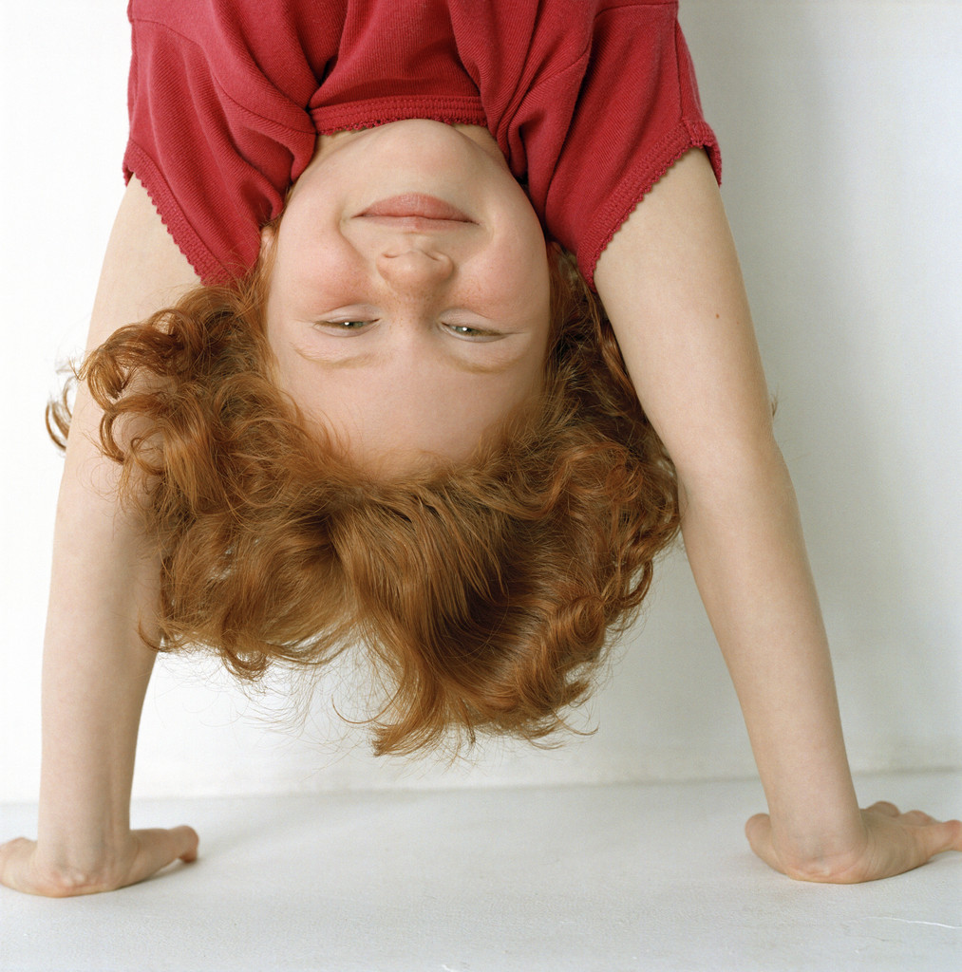
Replacement Behaviors:
- Following directions
- Saying “okay”
- Speaking with a pleasant voice
- Asking nicely to wait instead of being defiant

Acknowledgement Strategies:
- Premaking (a pre-explained reward contingency – example: “When you finish your chores you can have free time on the computer.”)
- Specific praise
- Preferred activity

Reactive Strategies:
- Provide time for the child to respond to directions
- Restate direction in a calm, clear fashion after providing time to process request,
- Comment on children who are following directions
- Don’t take it personally – be neutral
Aggression

Preventative Strategies:
- Teach problem solving steps to think through issues
- Teach about nice hands or keeping hands to self
- Provide training in relaxation and calming strategies
- Model problem solving behavior
- Have your child play with children who display positive problem solving behaviors
- Provide a “safe place” for the child to go for cooling down
- Teach child how to meet needs with out being aggressive
- Provide a menu of calming strategies for child to use before becoming aggressive
- Reframe the situations the child gets upset about

Replacement Behaviors:
- Verbal statements rather than hurting actions
- Walking away from disturbing situations
- Relaxation and calming strategies

- Reframing situations
- Hands and feet to self
- Follow problem solving steps

Acknowledgement Strategies:
- Opportunities to be a leader
- Thumbs up
- Verbal praise

Reactive Strategies:
- Calmly remind them of steps in problem solving
- Verbal De-escalation
- Avoid ultimatums
- If child needs to calm down, calmly take them to a time out space
- Have the child sit down with the “victim” (if the victim is willing) and hear how the aggression impacted them
Bullying

Preventative Strategies:
- Provide the child with responsibilities that cannot negatively impact other children
- Have the child engage in daily community building activities
- Provide clear restrictions against bullying
- Have discussions about bullying
- Watch movies that involve bullies and talk about them
- Teach empathy
- Limit exposure to violent media
- Provide safe opportunities for the bully to be vulnerable and express feelings
- Closely monitor the bully in unstructured situations

Replacement behaviors:
- Showing compassion and empathy toward others
- Helping behaviors
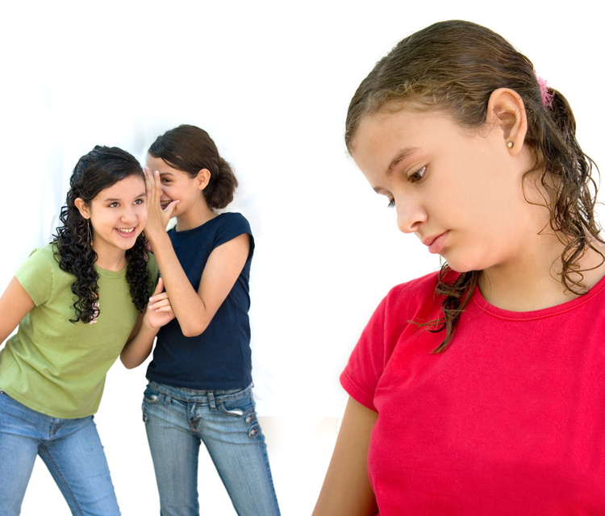
- Sincerely apologizing
- Doing nice things for others

Acknowledgement Strategies:
- Specific verbal praise
- Preferred activities

Reactive Strategies:
- Attend to the victim
- Privately talk to the bully
- Approach the child calmly to model positive behavior
- Be gentle rather than tough – once again modeling the desired behavior
- Do research on the effects of bullying and present it to the class
- Ask the bully for ideas of how to help the victim
Qualities of Strong Families

- Commitment

- Appreciation

- Time

- Congruence

- Purpose

- Communication

- Rules, Values and Beliefs

- Coping Strategies

- Problem Solving

- Ability to See the Positive

- Flexible, Adaptable and Balanced

Section 4
Appendix

Visual Supports

Specific Problem Behavior Worksheet

Matrix

Be Safe
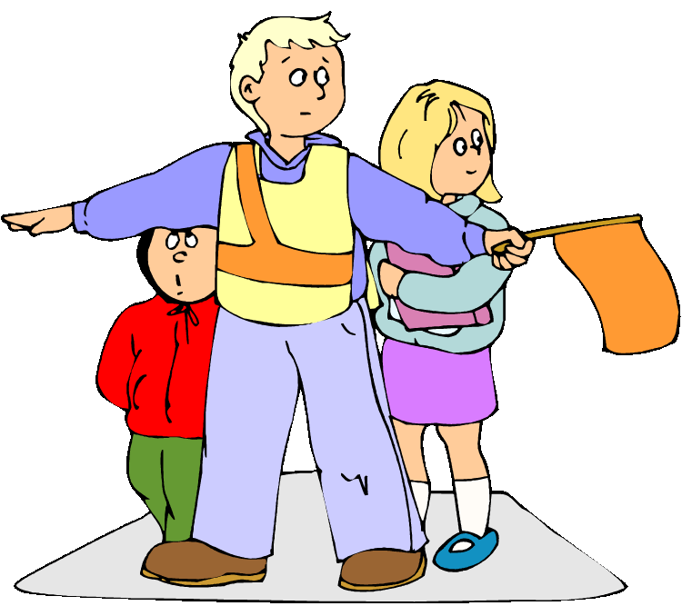

Be Respectful
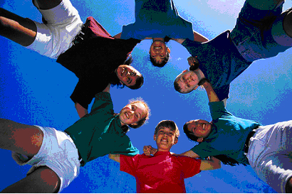

Be Responsible


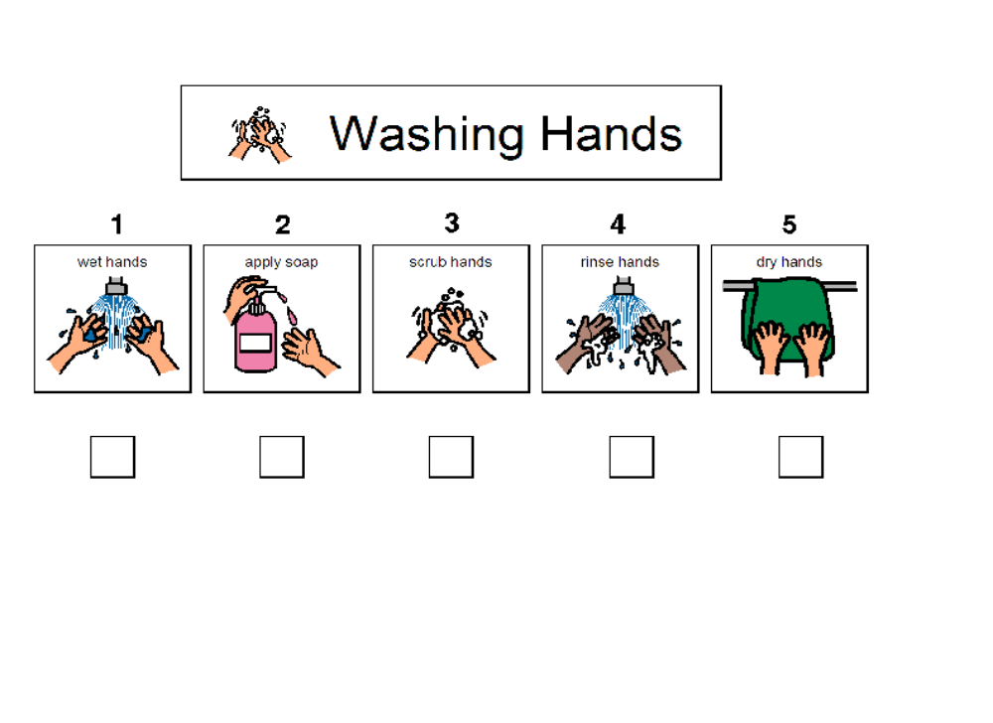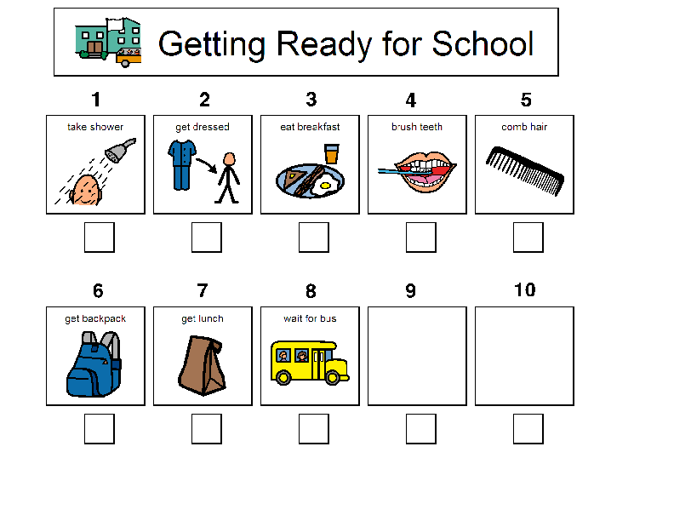

First Chores
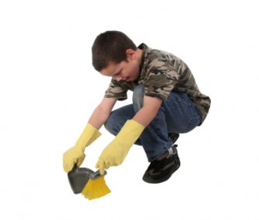

Then Play
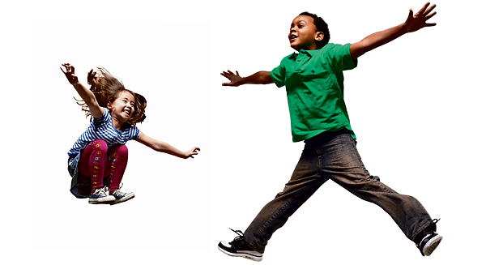

First

Then

Specific Problem Behavior Worksheet

What is the problem behavior? (state objectively):

What my child should do instead of the problem behavior? (state positively, list at least 2 behaviors)

What I will do to prevent the behavior or make it unnecessary? (Tone of voice, rephrase, change environment, change schedule, teach behaviors, teach routines, etc)

Behaviors I will acknowledge and things I will do to acknowledge them:

How I will react when the behavior occurs:

Specific Problem Behavior Worksheet

What is the problem behavior? (state objectively):

What my child should do instead of the problem behavior? (state positively, list at least 2 behaviors)

What I will do to prevent the behavior or make it unnecessary? (Tone of voice, rephrase, change environment, change schedule, teach behaviors, teach routines, etc)

Behaviors I will acknowledge and things I will do to acknowledge them:

How I will react when the behavior occurs:

Activities →

Expectations ↓

Activities →

Expectations ↓

Activities →

Expectations ↓

